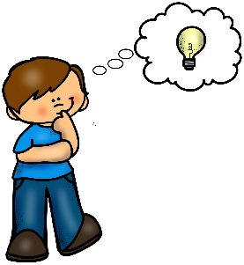
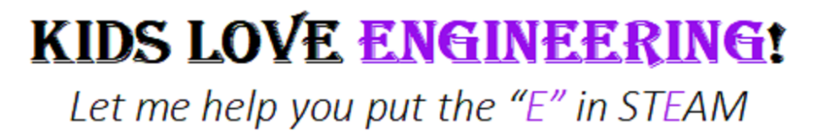
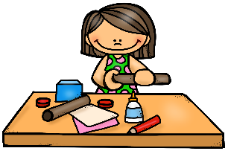

A Slick Solution: Cleaning an Oil Spill
Environmental Engineering
STAFF PROFESSIONAL DEVELOPMENT

1 Day Workshop Goals
Regardless of the specific unit and available time, all EiE PD workshops are focused on the same core goals and all EiE PD activities are designed to support educators who will use the EiE curriculum materials with their students. To do this, every EiE PD workshop aims to develop teachers’:

- confidence in teaching engineering.
- knowledge of the structure and types of learning activities within one or more EiE units.
- awareness of engineering as a field and of the Engineering Design Process (EDP), including how to apply the EDP to solve problems using technology.
- knowledge of technology as any object, system, or process designed by humans to solve a problem or fulfill a desire.

In addition to understanding the engineering content in a specific EiE unit, our workshops also have specific pedagogical goals:

- To put participants in active roles so they can experience a learner-centered experience. There is ample opportunity provided for exploring their questions and solving problems.
- To provide participants with opportunities to experience the power of science inquiry and reflect on implementing it in their classrooms.
- To allow participants to create their own conceptual understandings of engineering and the EiE unit by tapping into their prior knowledge of technology, engineering, and science.

This focus on the learner stems both from learning theory and from the efficacy of the EiE curriculum materials as measured by our research and assessment. We propose this hands-on, personal approach both to affect the teaching of engineering and to provide another method of reinforcing the related science content already being taught in the classroom. By modeling and demonstrating the power of hands-on science and engineering learning, the EiE program strives to influence educators to adopt more constructivist methods of teaching.

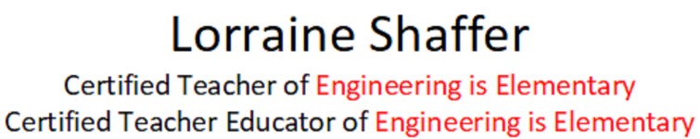

1 Day Workshop Agenda

What is Technology?  Technology in a Bag | Participants will:  - reflect upon personal knowledge of technology and engineering as well as students’ prior knowledge and misconceptions of technology.  - examine and discuss different technologies (objects, systems, and processes) and use their experiences to construct a working definition of technology.  - connect the development of technologies to the field of engineering.
What is Engineering?  Tower Power | Participants will:  - engage in a common engineering experience.  - realize that they naturally solve problems using a process similar to the EDP.  - develop the five-step EDP that forms the backbone of the EiE units.
Introduction to the EiE Program | Participants will learn about the background and goals of the EiE project.
Lesson 1  Tehya’s Pollution Solution | Participants will be introduced to the unit storybook, which will set the context for, and introduce content integral to, the rest of the unit.
Lesson 2  An Enviro-Mystery! | Participants will:  - be introduced to the Greentown pH testing activity  - reflect on how pollution can move from one part of the environment into another (e.g., from water into soil)  - understand how environmental engineers work to identify sources of pollution be gathering and interpreting data.
Lesson 3  A Slick Solution | Participants will:  - engage in participant-guided inquiry and discover that the EDP begins with asking questions, connect Lesson 3 with the EDP as a whole  - use and discuss a model showing how all of the organisms in a river ecosystem are connected to one another, and to the river itself.  - examine and test the available materials/ tools for their oil spill cleaning process designs (and relevant handouts).  - discuss testing methodology and ways to scaffold this topic with students
Lesson 4  Cleaning an Oil Spill | Participants will:  - use the data collected and analyzed from Lesson 3 to make connections about the efficacy of materials and tools and their oil spill cleaning process designs.  - use the Engineering Design Process to design an oil spill cleaning process.  - become familiar with the EDP handouts that students will use at each step of the design process.
Overview of the EiE Teacher Guide & Educator Resources | Participants will:  - learn how the EiE Teacher Guides are structured and the location of resources within the guides, such as planning charts, lesson plans, handouts, and assessments.  - be introduced to the resources available through the EiE Educator Resources website.

