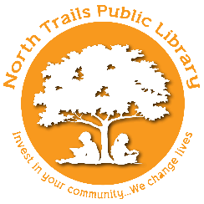
Child’s Name _______________________________________________________________________
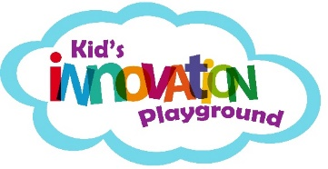

EMERGENCY RELEASE AND ACKNOWLEDGMENT FORM

We appreciate the opportunity to provide a technology experience for your child. Please note that this is a class area and not a childcare or day care center. For the courtesy and welfare of your child and others, please review our rules, completely fill out and sign the registration form.

- Each child must be registered by a parent/guardian.
- The parent/guardian that registers the child MUST be the same parent/guardian that picks up the child. This is for your child’s safety and protection. If another adult will be picking up/dropping off the child, the parent must sign that they are authorizing this.
- Staff may not administer any medication to any child.
- Children must be self-sufficient. Children with special needs must be accompanied by an adult.
- Participation in technology classes are at your own risk and liability. Kid’s Innovation Playground/North Trails Public Library, their agents, employees, and management cannot accept liability for any injury or damages that you or your child may suffer related to the class area. Any personal belongings, which enter the class area, are the responsibility of the parent/guardian.
- If an emergency or illness occurs while attending a class at KiP/NTPL, and the staff determines that the situation is life threatening or potentially hazardous to your child, your child's health, other children or any property, we may escort the child from the premises of KiP/NTPL. We may, at that time, request any personal, governmental or professional assistance which we deem necessary to protect the welfare of the child.

I have read, understand, and agree to abide by the rules stated above. I understand that my child is here at my own risk and liability. I agree that neither I nor my child will bring any claims of any kind or nature against Kid’s Innovation Playground/North Trails Public Library, their agents, employees, and management as a result of injuries, illness, expenses, or damages that I or my child may suffer which are in any way related to use of the class area or any form or object of entertainment offered in the class area, whether such claims are known, unknown, or arise in the future.

Parent/Guardian Name Phone #

Work Phone # Cell Phone #

Alternate Contact Person Phone #

Adult(s) authorized for pick up/drop-off of child _______________________________________

Any health concerns we should be aware of?

Parent/Guardian Signature __________________________________ Date Signed: / /

